**PRACTICAL NO. 02**

1. **Write the program for the following:**

**A)Write a function that takes a character (i.e. a string of length 1) and returns True if it is a vowel, False otherwise.**

**CODE:**

def vowel_consonant(k):

v = ['a' , 'e' , 'i' , 'o' , 'u','A','E','I','O','U']

if k in v :

return True

else :

return False

k = str(input("enter a single alphabet or string : "))

if vowel_consonant(k) :

print("it is vowel")

else :

print("it is not a vowel , it is alphabet")

**OUTPUT:**





**B)Define a function that computes the *length* of a given list or string.**

**CODE:**

def cal_length(a):

s=0

for x in a:

s=s+1

return s

ch=int(input("Enter 1 for string and 2 for list"))

if(ch==1):

b=input("Enter string: ")

print("Length of string is ",cal_length(b))

else:

list=[int(input("Enter list elements"))for x in range(5)]

print("Length of list is ",cal_length(list))

**OUTPUT:**

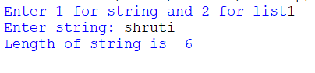

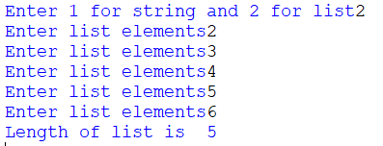

**C)Define a *procedure* histogram() that takes a list of integers and prints a histogram to the screen. For example, histogram([4, 9, 7]) should print the following: * * * \***

**\* * * * * * * * \***

**\* * * * * * \***

**CODE:**

def histogram(ls):

for i in ls:

print('*' * i)

lc = int(input('enter list count or size : '))

ls= list()

for b in range(lc):

l_val = int(input('enter value :'))

ls.append(l_val)

print('given list is :',ls)

print('list of integers and prints a histogram :')

histogram(ls)

**OUTPUT:**

